BSC – HGP - Assignment 02

Paint Application

UI Design Document

The paint application allows the user to make painting and graphics using different brush style, brush size, brush cap, brush color and brush join. The application also enables the user to import an image and make graphics on it. After using the application, the user may also save its painting.

The image below shows the painting application when the application is run.

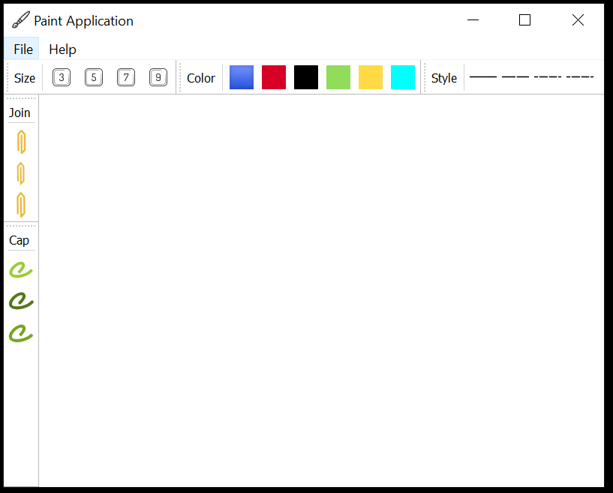The application consists of a menu bar and five tool bars.

***MenuBar***

The menu bar contains the File menu and Help menu.

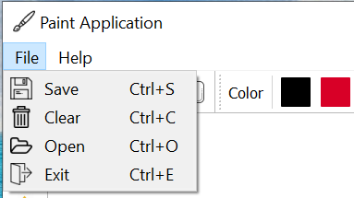

**File Menu**

The file menu contains the options Save, Clear, Open and Exit. By default, the options are written in black on a light grey background.

* Save

Save stores the painting as a picture in the location the user chooses. Save is represented by a save icon for better understanding. Save option also has a shortcut of “Ctrl+S”.

* Clear

Clear option deletes the current graphics on the screen. It is represented with a bin icon as it deletes the graphics. Clear option has a shortcut of “Ctrl+C”.

* Open

Open option opens an image that the user chooses from the desktop or a particular folder. It is represented by a folder icon. The user can edit the imported image and save it again. Open option has a shortcut of “Ctrl+O”.

* Exit

Exit option closes the painting application. It is represented by an icon pointing arrow away from a file. Exit option has a shortcut of “Ctrl+E”.

**Help Menu**

Help menu has two option namely Help and About. By default, the options are written in black on a light grey background. It is kept as default as it is better viewing for everyone.

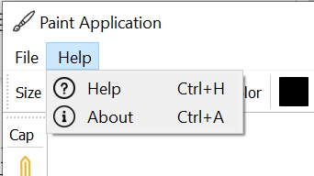

* Help

Help option has a shortcut of “Ctrl+H”. This option explains about the location of the brushes and their color and how to paint.

* About

About option has a shortcut of “Ctrl+A”. This option says that this application is a PyQt Application.

***Toolbar***

This painting application has five toolbars. Three toolbars are positioned under the menu bar in horizontal and two toolbars are positioned in vertical on the left.

The horizontal toolbar contains the size toolbar, color toolbar and style toolbar.

The vertical toolbar contains the cap toolbar and type toolbar.

The toolbars are moveable, they can move to any desired location of the user.

Brush Size toolbar

Brush Color toolbar

Brush Style toolbar



Brush Join Toolbar

Painting Area

Brush Cap toolbar

**Brush Size Toolbar:**

* Contain four icon of brush size, 3px, 5px, 7px and 9px
* The icon is small size to allow it to fit properly on the toolbar and it is also readable.
* It has black borders with the number written on it for better identification.
* A label is used to show which toolbar it is, a separator is also used to separate the label and the icons.
* The icon can also be easily accessed with shortcut such as “Ctrl+3”.

**Brush Color Toolbar:**

* This toolbar has six colors, black, red, green, yellow, blue, and cyan.
* The icon is small, and it is of the color of the brush.
* It also has hover effect which says which color it.
* A label is used to show which toolbar it is, a separator is also used to separate the label and the icons.
* The icon can also be accessed with shortcut.

**Brush Style Toolbar:**

* Style toolbar has four styles namely solid, dash, dot, dash dot dot.
* The icons are small with line style.
* A label is used to show which toolbar it is, a separator is also used to separate the label and the icons.
* The icons can be accessed with shortcut.

**Brush cap Toolbar**:

* This toolbar has three caps namely bevel, miter, round.
* A label is used to show which toolbar it is, a separator is also used to separate the label and the icons.
* The icons can be accessed with shortcut.
* The icons also have hover effect.
* The toolbar is placed on left hand side so that it does not overlap with the other toolbars.

**Brush Type Toolbar**:

* This toolbar has three types namely square, round, flat.
* A label is used to show which toolbar it is, a separator is also used to separate the label and the icons.
* The icons can be accessed with shortcut.
* The icons also have hover effect.

***Example painting made using this application:***

